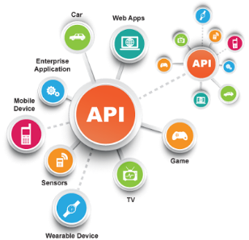**SE495 Software and Systems Integration**

**Developing an IoT Temperature Monitoring System**

**Project Description**

In this project, students will build a basic IoT system to monitor temperature in a room using an Arduino Uno, DHT11 temperature sensor and cloud platform like ThingSpeak. The system will have the following functionality:

1. Connect the DHT11 temperature and humidity sensor to the Arduino Uno
2. Program the Arduino to read data from the DHT11 sensor every 5 minutes
3. Connect the Arduino to the internet and a ThingSpeak channel to send temperature data
4. View the live temperature data on the ThingSpeak dashboard
5. Set up notifications to get alerts if temperature goes above a threshold

**The high-level steps would be:**

1. Set up the Arduino Uno and DHT11 sensor circuit
2. Create a ThingSpeak account and channel to store temperature data
3. Write code to read from DHT11 sensor and send data to ThingSpeak every 5 minutes
4. Upload the code to the Arduino and ensure it is sending data to the cloud
5. View the live temperature chart on the ThingSpeak dashboard
6. Set up email and SMS alerts for high temperature, e.g. > 30°C
7. Test the alerts by changing the room temperature and ensuring notifications are received
8. Review and discuss IoT integration benefits, challenges, security implications, etc.